IFT 266 Introduction to Network Information Communication Technology (ICT)
Lab 13
VLAN Setup and Configuration
After you complete each step, put a ‘√’ or ‘x’ in the completed box

Part A: VLAN Setup

Setup the following topology (we will connect the switch to router later on)
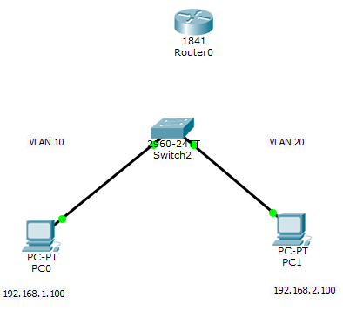

PC0 | IP Address: 192.168.1.100 | SM: 255.255.255.0 | DG: 192.168.1.1
PC1 | IP Address: 192.168.2.100 | SM: 255.255.255.0 | DG: 192.168.2.1

PC0 will be in VLAN 10 & PC1 will be in VLAN 20

- Now we need to configure the switch, the router and setup connections.
- PC0 connects to the switch via Fa0/1 via straight through cable
- PC1 connects to the switch via Fa0/10 via straight through cable



- We will first configure the switch. Click on the switch and then click the CLI tab

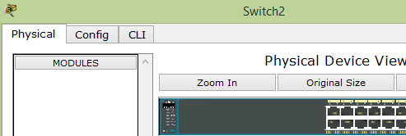

- We will now setup the VLANs on the switch with the following commands. Like a router, switches have different modes and, in each mode,, we can perform certain tasks.
The command ‘Enable’ gets us into the Privileged Exec mode and then the command ‘configure terminal’ gets you into global configuration mode.

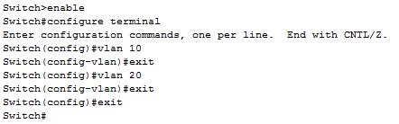

- Let’s look at the VLANs that we have setup by running the ‘show VLAN’ command.
We have the default VLAN – VLAN 1 (and on all ports on the switch are on VLAN 1, the default port)
We have VLAN 10 and VLAN 20 created but NO ports are associated with them, so we now need to associate ports with VLAN 10 and VLAN 20.

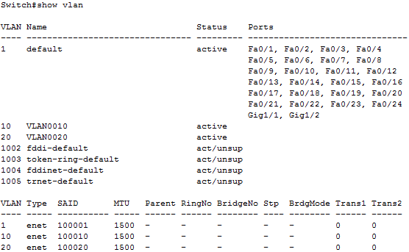

- Go back into Global Configuration Mode and type in the following commands.
By issuing these commands, port 1 (interface) will be configured to use VLAN 10 and port 10 will be configured to use VLAN 20.

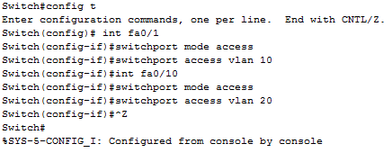

- Now we will issue the ‘show VLAN’ command we will see port 1 is part of VLAN 10 and port 10 is part of VLAN 20 and we have our PCs connected to these ports.
PC0 is connected to VLAN 10 and PC1 is connected to VLAN 20.

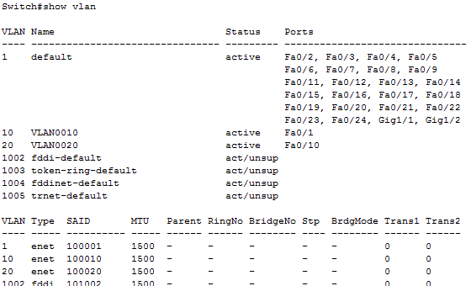

- Now setup the trunk on the switch.
Go back into the switch and will put the trunk on Port 24.
Once we configure the trunk onto to Port 24, we will save the configuration via the copy run start command. When you run this copy command, hit the return key to accept the default destination.
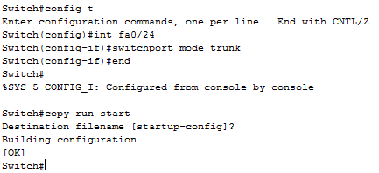

- Now we will test a few things….

Both PCs are connected to the switch but on separate VLANs so they should not be able to communicate with each other. We will prove this is true via a ping from PC0 to PC1. Even though they are connected to the same switch, they cannot communicate with each other as they are on separate VLANs i.e. the ping should time out so no communication.

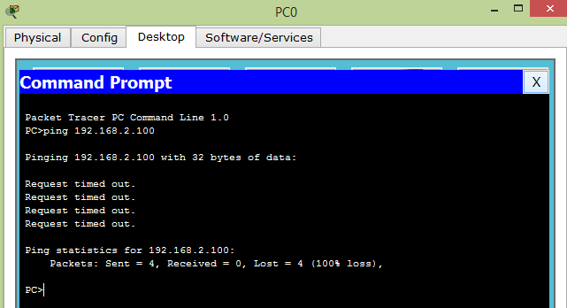

- Now connect the switch to the router via a straight through cable. Remember, we configured the trunk on Port 24 on the switch and we will use Port 0 on the Router.
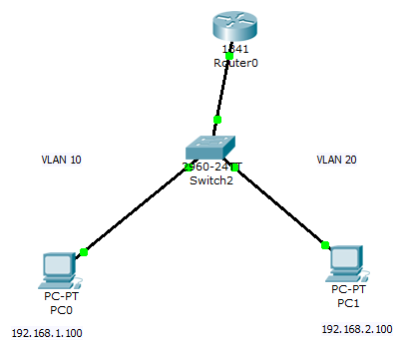

- Once the router is connected to the switch, will can now figure the router. Click on the router and then as the case with the switch, click the CLI tab to enter the IOS. Make sure you select ‘no’ to the system configuration dialog.
- Remember, we have configured the trunk on the switch side but we have no configuration on the router. We need to configure trunking for the router.

- Before we configure the trunking, we need turn on the router port (fa0/0) via the following commands
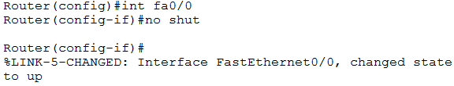

The link (connections) between the router and switch will now turn green.

- The cable should be connected to the Fast Ethernet 0/0 on the router (as previously stated), so we will now configure the router for sub interfaces and give sub interface (each network or VLAN) an IP address that this router will be part of. We have one interface which we need to split into 2 separate networks.
- Like with the switch, type the following commands into the router.
EEE 802.1Q is a standard protocol for interconnecting multiple switches and routers and for defining VLAN topologies. We need this command as the e syntax is different on a router than on a switch and the router runs a different version of IOS then a switch. The router connects to different networks, while the switch (unless it's a L3-switch) connects network-segments together. In other words, how the router and the switch will look at the frames and how they will forward the frames.

Use the encapsulation dot1q command in subinterface range configuration mode to apply a VLAN ID to the subinterface. We will enable dot1Q encapsulation on a subinterface for VLAN 10 and 20
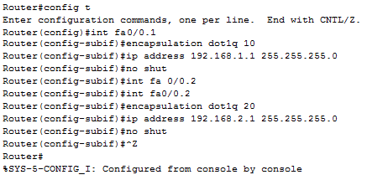

- We now use the show run command to show the current (running) configuration on the router and you will see the IP address showing on the sub interfaces. Interface 0/0 will have no IP address.
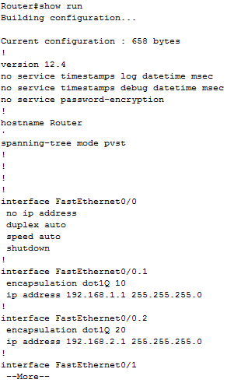

- Now we will run the show ip route command to show the routing table. Make sure all the relevant router ports are turned on. As you can see, .1 and .2 networks are directly connected on .1 and .2.

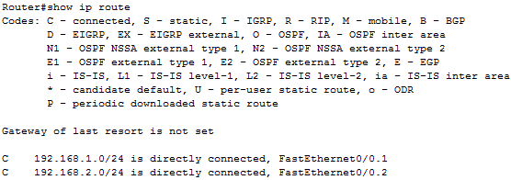

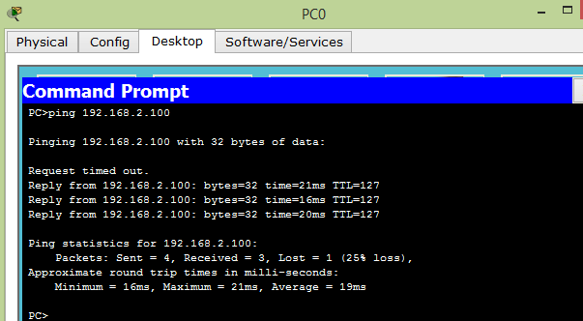
- Now we will test the network. If all works correctly, then the router should be able to route packets from PC0 to PC1.

- Router is routing across 2 VLANs and only 1 connection from the switch to the router but with two networks communicating with each other as the router can route traffic from one VLAN to the next.

